**Stat 5100 Handout 3.1.1 – SAS: Alternative Predictor Variable Types**

Example 1: (Table 8.1) Study looks at the effects of the charge rate and temperature on the life of a new type of power cell. A small-scale preliminary study was conducted using 11 power cells. Variables reported are the charge rate (X1, in amperes), the ambient temperature (X2, in degrees Celsius), and the life of the power cell (Y, in the number of discharge-charge cycles before failure).

**/* Input data -- see Table 8.1 in text */**

**data powercells;**

**input cycles charge_rate temperature; cards;**

**150 0.6 10**

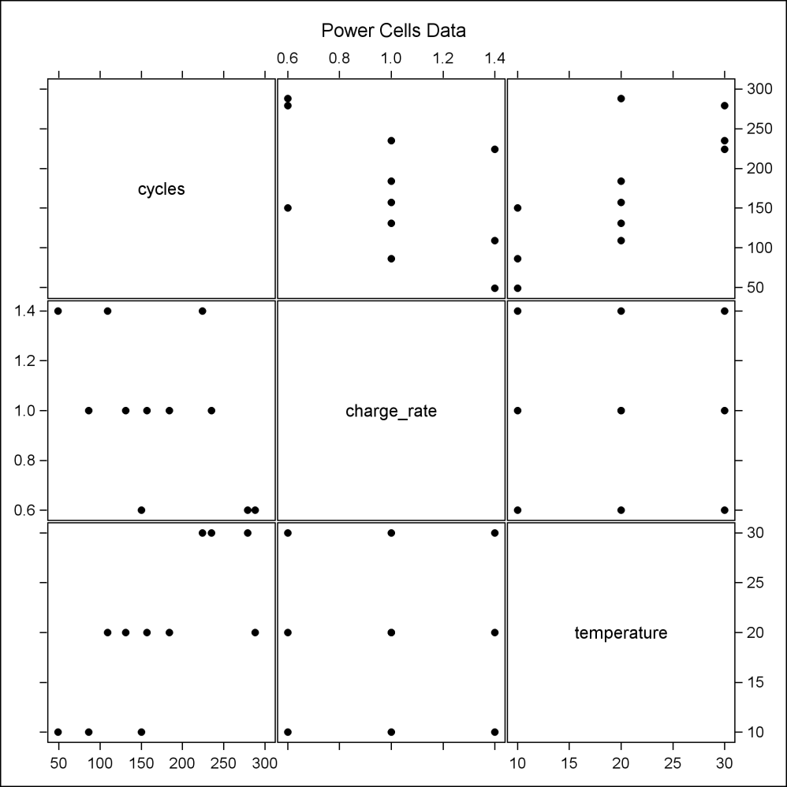 **86 1.0 10**

**49 1.4 10**

**288 0.6 20**

**157 1.0 20**

**131 1.0 20**

**184 1.0 20**

**109 1.4 20**

**279 0.6 30**

**235 1.0 30**

**224 1.4 30**

**;**

**run;**

**/* Look at shape of relationships with Y */**

**proc sgscatter data=powercells;**

**matrix cycles charge_rate temperature /**

**markerattrs=(symbol=CIRCLEFILLED size=2pt);**

**title1 'Power Cells Data';**

**run;**

**/* Define higher-order predictors */**

**data powercells; set powercells;**

**cr_temp = charge_rate*temperature;**

**cr2 = charge_rate**2;**

**temp2 = temperature**2;**

**run;**

**proc reg data=powercells;**

**model cycles = charge_rate temperature cr_temp / vif;**

**title1 'Check for interaction';**

**run;**

|  |  |  |  |  |  |  |  |  |  |  |  |  |  |  |  |  |  |  |  |  |  |  |  |  |  |  |  |  |  |  |  |  |  |  |  |  |  |  |  |  |  |  |  |  |  |  |  |  |  |  |  |  |  |  |  |  |  |  |  |  |  |  |  |  |  |  |  |  |  |  |  |  |  |
| --- | --- | --- | --- | --- | --- | --- | --- | --- | --- | --- | --- | --- | --- | --- | --- | --- | --- | --- | --- | --- | --- | --- | --- | --- | --- | --- | --- | --- | --- | --- | --- | --- | --- | --- | --- | --- | --- | --- | --- | --- | --- | --- | --- | --- | --- | --- | --- | --- | --- | --- | --- | --- | --- | --- | --- | --- | --- | --- | --- | --- | --- | --- | --- | --- | --- | --- | --- | --- | --- | --- | --- | --- | --- |
| |  | | --- | | ***Check for interaction*** |      | **Analysis of Variance** | | | | | | | --- | --- | --- | --- | --- | --- | | **Source** | **DF** | **Sum of Squares** | **Mean Square** | **F Value** | **Pr > F** | | **Model** | 3 | 53435 | 17812 | 17.39 | 0.0013 | | **Error** | 7 | 7171.33333 | 1024.47619 |  |  | | **Corrected Total** | 10 | 60606 |  |  |  |      | **Parameter Estimates** | | | | | | | | --- | --- | --- | --- | --- | --- | --- | | **Variable** | **DF** | **Parameter Estimate** | **Standard Error** | **t Value** | **Pr > |t|** | **Variance Inflation** | | **Intercept** | **1** | 218.08333 | 90.80890 | 2.40 | 0.0474 | 0 | | **charge_rate** | **1** | -197.08333 | 86.42997 | -2.28 | 0.0566 | 7.00000 | | **temperature** | **1** | 4.67500 | 4.20891 | 1.11 | 0.3034 | 10.37500 | | **cr_temp** | **1** | 2.87500 | 4.00093 | 0.72 | **0.4957** | 16.37500 | |

**proc reg data=powercells;**

**model cycles = charge_rate temperature cr_temp cr2 temp2**

**/ vif;**

**highercheck: test cr_temp=cr2=temp2=0;**

**title1 'Check for higher-order predictors';**

**run;**

|  |  |  |  |  |  |  |  |  |  |  |  |  |  |  |  |  |  |  |  |  |  |  |  |  |  |  |  |  |  |  |  |  |  |  |  |  |  |  |  |  |  |  |  |  |  |  |  |  |  |  |  |  |  |  |  |  |  |  |  |  |  |  |  |  |  |  |  |  |  |  |  |  |  |  |  |  |  |  |  |  |  |  |  |  |  |  |  |  |  |  |  |  |  |  |  |  |  |  |  |  |  |  |  |  |  |  |  |
| --- | --- | --- | --- | --- | --- | --- | --- | --- | --- | --- | --- | --- | --- | --- | --- | --- | --- | --- | --- | --- | --- | --- | --- | --- | --- | --- | --- | --- | --- | --- | --- | --- | --- | --- | --- | --- | --- | --- | --- | --- | --- | --- | --- | --- | --- | --- | --- | --- | --- | --- | --- | --- | --- | --- | --- | --- | --- | --- | --- | --- | --- | --- | --- | --- | --- | --- | --- | --- | --- | --- | --- | --- | --- | --- | --- | --- | --- | --- | --- | --- | --- | --- | --- | --- | --- | --- | --- | --- | --- | --- | --- | --- | --- | --- | --- | --- | --- | --- | --- | --- | --- | --- | --- | --- | --- | --- | --- |
| |  | | --- | | ***Check for higher-order predictors*** |  | **Analysis of Variance** | | | | | | | --- | --- | --- | --- | --- | --- | | **Source** | **DF** | **Sum of Squares** | **Mean Square** | **F Value** | **Pr > F** | | **Model** | 5 | 55366 | 11073 | 10.57 | 0.0109 | | **Error** | 5 | 5240.43860 | 1048.08772 |  |  | | **Corrected Total** | 10 | 60606 |  |  |  |        | **Parameter Estimates** | | | | | | | | --- | --- | --- | --- | --- | --- | --- | | **Variable** | **DF** | **Parameter Estimate** | **Standard Error** | **t Value** | **Pr > |t|** | **Variance Inflation** | | **Intercept** | **1** | 337.72149 | 149.96163 | 2.25 | 0.0741 | 0 | | **charge_rate** | **1** | -539.51754 | 268.86033 | -2.01 | 0.1011 | 66.21053 | | **temperature** | **1** | 8.91711 | 9.18249 | 0.97 | 0.3761 | 48.26974 | | **cr_temp** | **1** | 2.87500 | 4.04677 | 0.71 | **0.5092** | 16.37500 | | **cr2** | **1** | 171.21711 | 127.12550 | 1.35 | **0.2359** | 60.28708 | | **temp2** | **1** | -0.10605 | 0.20340 | -0.52 | **0.6244** | 38.97129 |  | **Test highercheck Results for Dependent Variable cycles** | | | | | | --- | --- | --- | --- | --- | | **Source** | **DF** | **Mean Square** | **F Value** | **Pr > F** | | **Numerator** | 3 | 819.96491 | 0.78 | **0.5527** | | **Denominator** | 5 | 1048.08772 |  |  | |

**proc reg data=powercells;**

**model cycles = charge_rate temperature;**

**title1 'Lower-order model';**

**run;**

|  |  |  |  |  |  |  |  |  |  |  |  |  |  |  |  |  |  |  |  |  |  |  |  |  |  |  |  |  |  |  |  |  |  |  |  |  |  |  |  |  |  |  |  |  |  |  |  |  |  |  |  |  |  |  |  |  |  |  |  |  |  |  |  |  |  |  |
| --- | --- | --- | --- | --- | --- | --- | --- | --- | --- | --- | --- | --- | --- | --- | --- | --- | --- | --- | --- | --- | --- | --- | --- | --- | --- | --- | --- | --- | --- | --- | --- | --- | --- | --- | --- | --- | --- | --- | --- | --- | --- | --- | --- | --- | --- | --- | --- | --- | --- | --- | --- | --- | --- | --- | --- | --- | --- | --- | --- | --- | --- | --- | --- | --- | --- | --- |
| |  | | --- | | ***Lower-order model*** |      | **Analysis of Variance** | | | | | | | --- | --- | --- | --- | --- | --- | | **Source** | **DF** | **Sum of Squares** | **Mean Square** | **F Value** | **Pr > F** | | **Model** | 2 | 52906 | 26453 | 27.48 | 0.0003 | | **Error** | 8 | 7700.33333 | 962.54167 |  |  | | **Corrected Total** | 10 | 60606 |  |  |  |      | **Parameter Estimates** | | | | | | | | --- | --- | --- | --- | --- | --- | --- | | **Variable** | **DF** | **Parameter Estimate** | **Standard Error** | **t Value** | **Pr > |t|** | **Variance Inflation** | | **Intercept** | **1** | 160.58333 | 41.61545 | 3.86 | 0.0048 | 0 | | **charge_rate** | **1** | -139.58333 | 31.66461 | -4.41 | 0.0023 | 1.00000 | | **temperature** | **1** | 7.55000 | 1.26658 | 5.96 | 0.0003 | 1.00000 | |

**/* Now look at higher-order variables with standardized data */**

**proc stdize data=powercells out=std_powercells**

**method=std mult=.3162;**

**run; /* Note that mult = 1/sqrt(n-1) */**

**data std_powercells; set std_powercells;**

**cr_temp = charge_rate*temperature;**

**cr2 = charge_rate**2;**

**temp2 = temperature**2;**

**run;**

**proc reg data=std_powercells;**

**model cycles = charge_rate temperature cr_temp / vif;**

**title1 'Check for interaction (standardized scale)';**

**run;**

|  |  |  |  |  |  |  |  |  |  |  |  |  |  |  |  |  |  |  |  |  |  |  |  |  |  |  |  |  |  |  |  |  |  |  |  |  |  |  |  |  |  |  |  |
| --- | --- | --- | --- | --- | --- | --- | --- | --- | --- | --- | --- | --- | --- | --- | --- | --- | --- | --- | --- | --- | --- | --- | --- | --- | --- | --- | --- | --- | --- | --- | --- | --- | --- | --- | --- | --- | --- | --- | --- | --- | --- | --- | --- |
| |  | | --- | | ***Check for interaction (standardized scale)*** |      | **Parameter Estimates** | | | | | | | | --- | --- | --- | --- | --- | --- | --- | | **Variable** | **DF** | **Parameter Estimate** | **Standard Error** | **t Value** | **Pr > |t|** | **Variance Inflation** | | **Intercept** | **1** | -1.431E-17 | 0.03920 | -0.00 | 1.0000 | 0 | | **charge_rate** | **1** | -0.55553 | 0.13001 | -4.27 | 0.0037 | 1.00000 | | **temperature** | **1** | 0.75122 | 0.13001 | 5.78 | 0.0007 | 1.00000 | | **cr_temp** | **1** | 0.28030 | 0.39008 | 0.72 | **0.4957** | 1.00000 | |

**proc reg data=std_powercells;**

**model cycles = charge_rate temperature cr_temp cr2 temp2**

**/ vif;**

**highercheck: test cr_temp=cr2=temp2=0;**

**title1 'Check for higher-order predictors (standardized scale)';**

**run;**

|  |  |  |  |  |  |  |  |  |  |  |  |  |  |  |  |  |  |  |  |  |  |  |  |  |  |  |  |  |  |  |  |  |  |  |  |  |  |  |  |  |  |  |  |  |  |  |  |  |  |  |  |  |  |  |  |  |  |  |  |  |  |  |  |  |  |  |  |  |  |  |  |  |  |  |  |  |  |
| --- | --- | --- | --- | --- | --- | --- | --- | --- | --- | --- | --- | --- | --- | --- | --- | --- | --- | --- | --- | --- | --- | --- | --- | --- | --- | --- | --- | --- | --- | --- | --- | --- | --- | --- | --- | --- | --- | --- | --- | --- | --- | --- | --- | --- | --- | --- | --- | --- | --- | --- | --- | --- | --- | --- | --- | --- | --- | --- | --- | --- | --- | --- | --- | --- | --- | --- | --- | --- | --- | --- | --- | --- | --- | --- | --- | --- | --- |
| |  | | --- | | ***Check for higher-order predictors (standardized scale)*** |  | **Parameter Estimates** | | | | | | | | --- | --- | --- | --- | --- | --- | --- | | **Variable** | **DF** | **Parameter Estimate** | **Standard Error** | **t Value** | **Pr > |t|** | **Variance Inflation** | | **Intercept** | **1** | -0.03720 | 0.06745 | -0.55 | 0.6051 | 0 | | **charge_rate** | **1** | -0.55553 | 0.13150 | -4.22 | 0.0083 | 1.00000 | | **temperature** | **1** | 0.75122 | 0.13150 | 5.71 | 0.0023 | 1.00000 | | **cr_temp** | **1** | 0.28030 | 0.39455 | 0.71 | **0.5092** | 1.00000 | | **cr2** | **1** | 0.66773 | 0.49577 | 1.35 | **0.2359** | 1.07656 | | **temp2** | **1** | -0.25850 | 0.49577 | -0.52 | **0.6244** | 1.07656 |  | **Test highercheck Results for Dependent Variable cycles** | | | | | | --- | --- | --- | --- | --- | | **Source** | **DF** | **Mean Square** | **F Value** | **Pr > F** | | **Numerator** | 3 | 0.01353 | 0.78 | **0.5527** | | **Denominator** | 5 | 0.01729 |  |  | |

**/* NOTE: You don't need to standardize predictors to look at**

**higher-order predictors like this. Instead, you can**

**include a higher-order predictor and test it; if**

**not significant, drop it; if significant, don't worry**

**about significance of lower-order term. If higher-order**

**term is significant and you really need to look at**

**significance of lower-order term, or if the context of**

**the data would allow the lower-order and higher-order**

**terms to be 'stand-alone' interpretable, then**

**standardize.**

**Tests for higher-order terms are the same whether**

**data are standardized or not.**

**\*/**

Example 2: An economist wishes to relate the speed with which a particular insurance innovation is adopted (Y, in months) to the size of the insurance firm (X1, in millions of dollars) and the type of firm (X2, either mutual (0) or stock firms (1)).

**/* Input data -- see Table 8.2 of text */**

**data insurance; input months size type @@; cards;**

**17 151 0 26 92 0 21 175 0 30 31 0**

**22 104 0 0 277 0 12 210 0 19 120 0**

**4 290 0 16 238 0 28 164 1 15 272 1**

**11 295 1 38 68 1 31 85 1 21 224 1**

**20 166 1 13 305 1 30 124 1 14 246 1**

**;**

**/* Model with only quantitative predictor */**

**proc reg data=insurance;**

**model months = size;**

**title1 'Single quantitative predictor';**

**output out=out1 p=pred;**

**run;**

|  |  |  |  |  |  |  |  |  |  |  |  |  |  |  |  |  |  |  |  |  |  |  |  |  |  |
| --- | --- | --- | --- | --- | --- | --- | --- | --- | --- | --- | --- | --- | --- | --- | --- | --- | --- | --- | --- | --- | --- | --- | --- | --- | --- |
| |  | | --- | | ***Single quantitative predictor*** |      | **Parameter Estimates** | | | | | | | --- | --- | --- | --- | --- | --- | | **Variable** | **DF** | **Parameter Estimate** | **Standard Error** | **t Value** | **Pr > |t|** | | **Intercept** | **1** | 36.48211 | 2.84425 | 12.83 | <.0001 | | **size** | **1** | -0.09394 | 0.01426 | -6.59 | <.0001 | |

**/* Model with only qualitative predictor */**

**proc reg data=insurance;**

**model months = type;**

**title1 'Single qualitative predictor';**

**run;**

|  |  |  |  |  |  |  |  |  |  |  |  |  |  |  |  |  |  |  |  |  |  |  |  |  |  |
| --- | --- | --- | --- | --- | --- | --- | --- | --- | --- | --- | --- | --- | --- | --- | --- | --- | --- | --- | --- | --- | --- | --- | --- | --- | --- |
| |  | | --- | | ***Single qualitative predictor*** |  | **Parameter Estimates** | | | | | | | --- | --- | --- | --- | --- | --- | | **Variable** | **DF** | **Parameter Estimate** | **Standard Error** | **t Value** | **Pr > |t|** | | **Intercept** | **1** | 16.70000 | 2.92024 | 5.72 | <.0001 | | **type** | **1** | 5.40000 | 4.12984 | 1.31 | 0.2075 | |

**proc sort data=insurance out=sort_ins; by type;**

**proc boxplot data=sort_ins;**

**plot months*type /**

**boxstyle=schematic boxwidth=30 haxis=axis1**

**cboxfill=yellow cboxes=blue;**

**axis1 order=(.5 to 1.5 by .5);**

**run;**

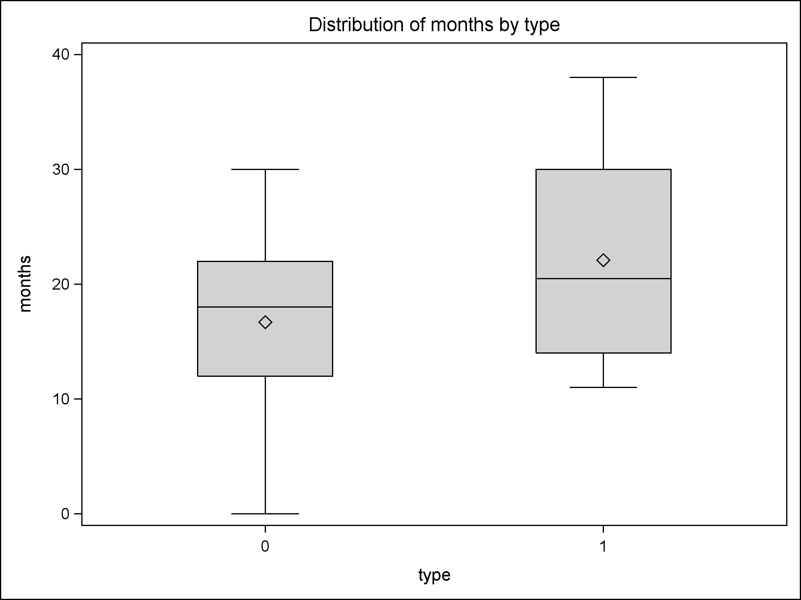

**/* Additive model */**

**proc reg data=insurance;**

**model months = size type;**

**title1 'Additive model';**

**run;**

|  |  |  |  |  |  |  |  |  |  |  |  |  |  |  |  |  |  |  |  |  |  |  |  |  |  |  |  |  |  |  |  |
| --- | --- | --- | --- | --- | --- | --- | --- | --- | --- | --- | --- | --- | --- | --- | --- | --- | --- | --- | --- | --- | --- | --- | --- | --- | --- | --- | --- | --- | --- | --- | --- |
| |  | | --- | | ***Additive model*** |      | **Parameter Estimates** | | | | | | | --- | --- | --- | --- | --- | --- | | **Variable** | **DF** | **Parameter Estimate** | **Standard Error** | **t Value** | **Pr > |t|** | | **Intercept** | **1** | 33.87407 | 1.81386 | 18.68 | <.0001 | | **size** | **1** | -0.10174 | 0.00889 | -11.44 | <.0001 | | **type** | **1** | 8.05547 | 1.45911 | 5.52 | <.0001 | |

**/* Define predicted values for each type level, by hand,**

**and look at fitted lines */**

**data insurance; set insurance;**

**pred0 = 33.87407 - .10174*size;**

**pred1 = 33.87407 - .10174*size + 8.05547;**

**proc sort data=insurance;**

**by size type;**

**proc sgplot data=insurance;**

**scatter x=size y=months /**

**markerchar=type markercharattrs=(size=12pt);**

**series x=size y=pred0 / lineattrs=(pattern=solid);**

**series x=size y=pred1 / lineattrs=(pattern=dash);**

**run;**

|  |  |
| --- | --- |
|  |  |

**/* Interaction model */**

**data insurance; set insurance;**

**size_type = size*type;**

**proc reg data=insurance;**

**model months = size type size_type;**

**title1 'Interaction model';**

**run;**

|  |  |  |  |  |  |  |  |  |  |  |  |  |  |  |  |  |  |  |  |  |  |  |  |  |  |  |  |  |  |  |  |  |  |  |  |  |  |
| --- | --- | --- | --- | --- | --- | --- | --- | --- | --- | --- | --- | --- | --- | --- | --- | --- | --- | --- | --- | --- | --- | --- | --- | --- | --- | --- | --- | --- | --- | --- | --- | --- | --- | --- | --- | --- | --- |
| |  | | --- | | ***Interaction model*** |  | **Parameter Estimates** | | | | | | | --- | --- | --- | --- | --- | --- | | **Variable** | **DF** | **Parameter Estimate** | **Standard Error** | **t Value** | **Pr > |t|** | | **Intercept** | **1** | 33.83837 | 2.44065 | 13.86 | <.0001 | | **size** | **1** | -0.10153 | 0.01305 | -7.78 | <.0001 | | **type** | **1** | 8.13125 | 3.65405 | 2.23 | 0.0408 | | **size_type** | **1** | -0.00041714 | 0.01833 | -0.02 | 0.9821 | |

**data insurance; set insurance;**

**pred0 = 33.83837 - .10153*size;**

**pred1 = 33.83837 - .10153*size + 8.13125 - .0041714*size;**

**proc sort data=insurance; by size type;**

**proc sgplot data=insurance;**

**scatter x=size y=months /**

**markerchar=type markercharattrs=(size=12pt);**

**series x=size y=pred0 / lineattrs=(pattern=solid);**

**series x=size y=pred1 / lineattrs=(pattern=dash);**

**run;**

